EML Handbook

Written by
David Blankman
Jeanine McGann
LTER Network Office
University of New Mexico
Albuquerque, NM
© 2003

EML
Who should read this?

This document is designed for ecologists, ecological information managers, and ecology students as a general introduction to the Ecological Metadata Language, EML. It covers EML’s overall structure, and some of the more critical and typical aspects of its usage. In particular, this document is intended to provide a rapid entry into understanding the meaning of some selected EML fields that are of great general utility. For those seeking a more technical or comprehensive overview of EML, please see XXXXX (reference normative docs, FAQ, tutorial, others?).

This document assumes a basic level of computer knowledge, and some experience working with ecological data

Introduction

What is EML?

Ecological Metadata Language (EML) is a metadata content specification for ecological data, resulting from a community-based effort involving ecological researchers, information managers, and software developers from around the United States, in particular at Long Term Ecological Research sites, LTER, and the National Center for Ecological Analysis and Synthesis, NCEAS. The need for EML has long been recognized within the ecological community as critical to the preservation and long-term intelligibility of the growing archives of ecological data (FLED Report 1995, Michener et al, 1997). EML was also designed to assist the individual researcher in managing and more effectively using their own data. EML attempts to be non-ambiguous and comprehensive, and is intended for use by any ecologist or ecological information manager who wishes to document their data in a way that facilitates its reusability and sharing.

EML describes a number of critical aspects of the data, such as variables’ names and definitions, their units of measurement, time and place of data collection, who collected the data, etc. Much of this information is currently collected by ecologists in various forms—such as field notes, or marginalia, and hence are subject to being lost, separated from the data, or stored in very arbitrary ways. These disadvantages are eliminated by using a more formal and standard framework such as EML. Even in the case of existing data catalogs, the terminology and types of metadata collected vary widely, whereas EML provides a standardized set of terms and definitions intended specifically for ecological metadata.

EML.is implemented in XML (Extensible Markup Language), which is a growing standard for marking up documents on the Web. This means that metadata created in EML will be highly available for searching and exchanging over the Web, if so desired. This formal structure for EML not only provides a common structure for ecologists to document and interpret ecological data, but also one that better enables efficient development of software applications that process the metadata. The kinds of technology applications anticipated range from basic tools that allow users to perform specific targeted searches for datasets, to advanced applications that can perform automatic integration of datasets. This will be a tremendous help to ecologists in organizing and implementing long-term research studies, where the ability to search for and synthesize large amounts of data is crucial.

EML is essentially a set of pre-defined terms, which are called “tags” or “elements” in the technical vernacular. These tags are simply names for different types of metadata items, and the values or content placed within a tag represents the actual metadata. Aside from the tags themselves, EML also includes some rules that specify what type of content can be used within a given tag, or how many instances of a given tag can be used for a particular data set, etc. For example, the tag called “abstract” should contain information (metadata) that is a “brief overview of the resource or data being documented”. There should be one “abstract” per data resource, and it should contain character/textual information. Thus the value of a tag called “abstract” for a particular data set might be:

“This dataset contains demographic information on the survival and reproduction of barbed goat grass (Aegilops triuncialis)populations reciprocally transplanted between core and edge sub-populations along an invasion front located at the Mclaughlin reserve. The purpose of the study is to examine the potential for rapid evolutionary change along invasion fronts of this exotic grass. The study will probably end in Summer 2003.”

Notice that this use of “abstract” matches with our popular conception of the definition of an abstract. EML attempts to use familiar terms with intuitively corresponding definitions whenever possible. However, often the need for consistency and reduction of ambiguity have forced the adoption of more technically accurate terms for EML metadata tags, even when some other term might be widely used by practicing ecologists. For example, we use the term “attribute” to refer to what ecologists frequently call a “variable” -- referring to data of a given type contained within a column of a data table. This naming choice corresponds with formal use in database terminology. Other alternative names for “attribute” might have included “field” or “column header”. When facing choices like this, EML strives to adopt the most technically appropriate choice (although there is often heated debate among EML contributors about what this best choice might be!)

Another example would be a tag called “creator”, which contains the full name of the person, organization, or position which created a data resource. A value for such a tag might consist of the values for tags containing surname information, as well as given name information. Note that EML contains nested tags, such that we can talk about a concept like “creator”, which contains tags for surname and given name. Again, EML also contains rules about how these tags can be nested and filled out, but we reserve discussion of such technical details for Appendix X.

EML, then, is a set of tags (written in XML) that correspond to ecological data or metadata, and a set of rules for how these tags should be used. Software tools such as “morpho” can assist in the process of creating EML, by making the XML structure appear much more attractive, and hiding some of the formal complexities of the XML, in the same way that a Web browser such as Netscape makes HTML marked-up text look good.
For the purposes of this document, except for the Appendix, formal EML tag names will be consistently represented in bold monospace, with the tag value consisting of the content following the colon--

title: Rodents of the Southwest

We have adopted this format to simplify and clarify the presentation of EML. The formal representation of tag structures within XML (and hence, EML) is somewhat different—

<title>Rodents of the Southwest</title>

This format, however, is generally hidden from the ecologist who will be creating and modifying their metadata, so it will not be used in the main body of this document.

Modular Design of EML

EML is subdivided into a number of modules that operate together to provide a comprehensive solution for ecological metadata. This modularization is primarily to assist information managers in selecting only those aspects of metadata which are of importance to their organizational needs, as well as to provide for easier flexibility and integration with other possible metadata standards. The modular design of EML will usually be hidden from the individual scientists who are using EML.

Still, it is useful to understand that these modules do exist in EML, and are designed to encompass broad areas of thematic interest. A module would include issues such as 1) basic descriptions about data set ownership—who, what, where, when, and why; or 2) descriptions about how the data are actually structured; or 3) what are the distribution rights for the data? For example, below we list some general metadata concepts along with their appropriate EML tags--

1. Ownership

Who did the research? (creator)
In general terms, what is the research about? (abstract)
What are some of the key concepts addressed by the data? (keywords)
Where was the research done? geographic coverage)
What time periods are covered in the data? (temporal coverage)
What species are represented in this research/data? (taxonomic coverage)
What methods were used? (methods)
Is the data being documented part of a larger project (project)

2. Data structure
The data representation branch contains modules that are used to describe:
What kind of data entity is it? (e.g., Table or Raster)
What are the names of variables within the data set? (attribute name)

3. Distributional information

How would I retrieve this file? (physical)/(distribution)
Who will I allow access to the data? (access)

The list above is only a very small sample of the modules and tags within EML. The primary challenge in creating EML is to understand which tag to use for which type of metadata, and then to properly fill in the tags which are critical to your (and others) needs. In addition, as a researcher, you might benefit by reviewing the overall EML set of tags, as you might discover critical types of metadata worth documenting that you hadn’t previously considered.

The rest of this document will examine EML in more detail, with specific examples intended to rapidly familiarize ecologists with the meaning and appropriate use of many common types of ecological metadata

A Simple Case Example

You have just completed a research project on rodent populations at a “well-known” Field Station in northwestern New Mexico. You are interested in creating EML-compliant metadata to document your research so that it can be loaded onto the Field Station’s EML metadata catalog. These metadata will enable other investigators to become aware of your work through Internet searches, while also serving as a durable “cataloguing” of the data set for your own convenience.

Q: What is the minimum set of metadata you need to create a valid EML document?

A: Figure 2 shows the smallest valid EML document, which consists of a dataset tag, which in turn contains tags for a title, creator, and contact. Note the nesting of tags, such that some might contain actual metadata values (e.g. title), while others contain further tags that have values (e.g., creator contains the tag for individualName, which consists of tags for surName and givenName).

Figure 2
The smallest valid EML Document

<?xml version="1.0"encoding="UTF-8"?>
<eml:eml>
packageId="eml.1.1"system="knb"
xmlns:eml="eml://ecoinformatics.org/eml-2.0.0"
xmlns:xsi="http://www.w3.org/2001/XMLSchema-instance"
xmlns:ds="eml://ecoinformatics.org/dataset-2.0.0"
xsi:schemaLocation="eml://ecoinformatics.org/eml-2.0.0 eml.xsd">
<dataset>
<title>Rodents of the Southwest</title>
<creator>
<individualName>
<surName>Ecosis</surName>
</individualName>
</creator>
<contact>
<individualName>
<surName>Ecosis</surName>
</individualName>
</contact>
</dataset>
</eml:eml>

All XML documents start with this. Most XML documents use UTF-8
also known as Unicode xmlns is short for XML Namespace.
These fields are the minimum necessary to produce a valid

EML dataset document:
<title>
<creator>
<contact>
must be unique for the SYSTEM

You can see that this basic EML document doesn’t tell anyone very much—just some basic contact information and indication of content, if the title is well composed. Better than nothing, but--.
what additional elements might provide sufficient information to enable other scientists to determine whether, say, some fruitful collaboration could result from sharing or combining your data?

That’s a longer story…and it’s going to require some definitions and more detailed explanations. It will help us to look more closely at the structure of the minimal EML document.

Documenting a dataset

The fundamental “object” for which an ecologist might want to create metadata is termed a “dataset” in EML. “dataset” means different things to different people. In EML, the term may contain general information such as the title, creator, and contacts, as well as one or more data entities, such as data tables, that provide more specific research details. Take a look at the expanded EML dataset schema displayed in Figure 3. This schema provides a graphical representation or “map” of the actual XML schema that shows where the different elements fit in the hierarchy of the language.

Figure 3
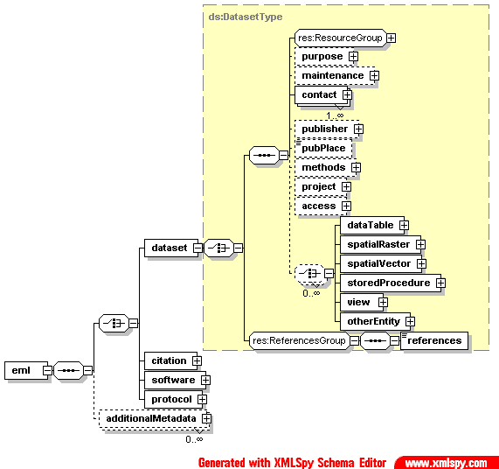

For the moment, let’s focus on the ResourceGroup schema, which is displayed in Figure 4. The <title> field provides a description of the resource being documented that is long enough to differentiate it from other similar resources. Multiple titles may be provided, particularly when trying to express the title in more than one language. If a title is in a language other than English, use the “xml:lang” attribute. For example,

<title>Rodents of the Southwest</title>
<title>xml:lang=”de”Rodents des Südwestens</title>

In the second <title>, the text ‘xml:lang=“de”’ is an XML attribute that says: language =german (de=deutsche). There are two versions of ISO 639 language codes: two-letter
or three-letter codes. The three-letter system was designed to expand the list of languages that can be represented. Currently, the two-letter system is used more often, but over time it is likely that the three-letter system will be embraced.

A clear discussion of the use of the language attribute can be found at: http://msdn.microsoft.com/library/default.asp?url=/library/en-us/prompting_beta2/html/SSML_Elements_lang.asp.

The actual language codes can be found at: http://www.w3.org/WAI/ER/IG/ert/iso639.htm.

Figure 4
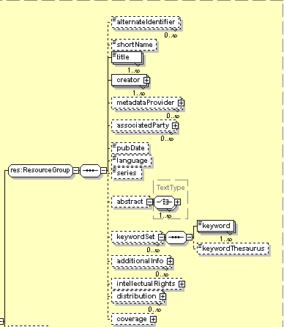

A <creator> is a structure for representing the owner of the data. A <creator> can be a person, an organization, or an organizational role. Examples of organizational roles are: Executive Director, Department Administrator, or Information Manager.

At this point, we can expand the minimal EML document to look at the <creator> information in more detail.

...<creator>
<individualName>
<salutation>Dr.</salutation>
<givenName>Pat</givenName>
<givenName>Morgan</givenName>
<surName>Ecosis</surName>
</individualName>
<address>l
<deliveryPoint>Department of Southwestern Ecology</deliveryPoint>
<deliveryPoint>Semiarid State University</deliveryPoint>
<city>Noaguaville</city>
<administrativeArea>NM</administrativeArea>
<postalCode>78890</postalCode>
<country>USA</country>
</address>
<phone>709-345-8970 x 254</phone>
<electronicMailAddress>pat.ecosis@semiarid.edu</electronicMailAddress>
</creator>
<creator>
<organizationName>USDA</organizationName>
<address>
<deliveryPoint>U.S. Department of Agriculture</deliveryPoint>
<deliveryPoint>Mailstop 3654</deliveryPoint>
<deliveryPoint>25 Federal Plaza</deliveryPoint>
<city>Washington</city>
<administrativeArea>DC</administrativeArea>
<postalCode>20025</postalCode>
<country>USA</country>
</address>
<phone>phonetype=”voice”709-345-8970 x 254</phone>
<phone>phonetype=”fax”709-345-8962</phone>
<electronicMailAddress>dataservices@usda.gov</electronicMailAddress>
<onlineUrl>http://www.usda.gov/ecoinformatics/</onlineUrl>
</creator>

The element names may seem unfamiliar and you might be wondering why the developers of EML used such strange names. These elements have been taken from the International Standards Organization (ISO), schema for representing people: iso-party.

For example, a person can have more than one <givenName>, but only one <surname>. EML does not have a specific tag for middle names. Since <givenName> is optional, <surName> would be used for “Cher” or “Madonna.”

An address can have more than one <deliveryPoint>. A <deliveryPoint> is that part of an address that precedes the <city>. The most common <deliveryPoint> is a street address. Other examples are company names, department names, or post office boxes. Because XML does not recognize carriage returns, the way to enter that part of an address that precedes the city is to use a separate <deliveryPoint> element for each item that you would want to appear on a separate line when displayed on a web page or printed report. An <administrativeArea> is the tag that would be used in the United States to represent a state or in Canada to represent a province.

A <creator> can have more than one address. Each address must be contained in its own set of <address></address> tags:

…<creator>
<individualName>
<salutation>Dr.</salutationr>
<givenName>Joe</givenName>
<surName>Ecologist</surName>
</individualName>
<address>
<deliveryPoint>25 Oceans Avenue</deliveryPoint>
<city>Oceans</city>
<administrativeArea>CA</administrativeArea>
<postalCode>98025</postalCode>
</address>
<address>
<deliveryPoint>Department of Ecological Sciences</deliveryPoint>
<deliveryPoint>University of the Oceans</deliveryPoint>
<city>Oceans</city>
<administrativeArea>CA</administrativeArea>
<postalCode>98025</postalCode>
</address>
</creator>

In terms of EML schema, the above code fragment would look something like this:

Figure 5
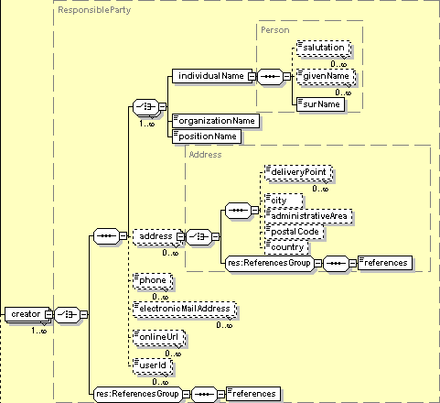

There are two additional optional creator types that can be described by EML, <metadataProvider> and <associatedParty>. A <metadataProvider> can be used if the person, organization, or organizational position that provided the metadata is not the one who created the data being documented. A <metadataProvider> could be an LTER information manager, a student, or a researcher who may or may not have been part of the data creation process. While this field is optional, it is recommended that it be used if the metadata was provided by someone other than the <creator>.

It is also a good idea to use this if there are multiple creators, but one of them is the primary source of the metadata. It is especially important to use this structure if the metadata is being constructed after the fact. For example, if someone decides to create EML documentation for data that is 20 years old, some metadata may exist in a lab notebook, but the documenter also is developing new metadata.

An <associatedParty> is a person, organization, or organizational position that is involved in the creation of the data, but is neither a <creator> nor a <metadataProvider>. An associated party could be a researcher, statistician, technician, or an advisor or consultant. If the research data was developed by a team of researchers, the principal investigator might be the <creator>, while her associates could be described by <associatedParty>. The schemas for both <metadataProvider> and <associatedParty> have essentially the same structure as that of <creator>, however, it should be noted that <associatedParty> also contains a mandatory element called <role>, which is used to define the role that the party played in relation to the research being documented, such as “research assistant,” or “technician.”

As mentioned earlier, the structure of an EML document is defined by a series of XML schemas. The schema determines not only the names of valid tags, but also the order of the various structures. As can be seen in Figure 4, a <creator> must be described before a <metadataProvider>, and a <metadataProvider> before an <associatedParty>.

Aside from names and addresses, the ResourceGroup schema also is used to provide an overview of the information in the dataset. Some of the more useful ResourceGroup elements include <abstract>, <keywordSet>, <distribution>, and <coverage>. While they are not required elements, both <abstract> and <keywordSet> are useful for describing the general nature of the research being documented, especially when the data is being designed for use with a search engine. The <distribution> and <coverage> elements reappear in later modules, and as they are also optional, they will be discussed later. All of these elements, however, should be listed after the <creator>, <metadataProvider>, and <associatedParty>.

In the <abstract> section, each paragraph is separated by the <para></para> tagset, while each section is enclosed in the <section></section> tagset. For most abstracts, there will be only one section.

As for keywords, the entire set is defined by the <keywordSet> tags, while each individual keyword is separated by a <keyword></keyword> tagset.

…<abstract>
<section>
<para>Small mammal species are often affected by changes in vegetation composition and structure. In the southwestern United States, many large recent burns have altered the structure and function of piñon ecosystems. These burns have affected the structure of the dead wood habitats of many mouse species. In this study, small mammals in a northern New Mexico piñon and juniper forest were live-trapped in a non-burn area and it was found that mouse species (especially Peromyscus species) were associated with many dead wood habitats.
</para>
</section>
</abstract>
<keywordSet>
<keyword>pinon forest</keyword>
<keyword>Peromyscus maniculatus</keyword>
<keyword>deer mouse</keyword>
<keyword>New Mexico</keyword>
</keywordSet>

The next element to be added after the abstract and keywords is the contact information. A <contact> is a structure for representing the person, organization, or organizational role to contact regarding the use of the data. Although <contact> followed <creator> in the minimal EML document in Figure 2, a closer look at Figures 3 & 4 reveals that <creator>, <metadataProvider>, and <associatedParty> are part of the larger structure of the ResourceGroup, while <contact> is located just below the ResourceGroup in the schema. Any elements that are used in the ResourceGroup must be entered before the next set of elements <purpose> (optional), <maintenance> (optional), and <contact> (required).

Without getting too deep into the language of XML schema, we can say that both the <contact> and <creator> elements have the same structure, that is, both are “of type ResponsibleParty.” The <contact> information follows the same structure as the <creator> information with regard to address and phone and online resources.

…<contact>
<positionName>Information Manager</positionName>
<address>
<deliveryPoint>Oceans LTER</deliveryPoint>
<deliveryPoint>Department of Marine Ecology</deliveryPoint>
<deliveryPoint>University of the Oceans</deliveryPoint>
<deliveryPoint>1514 San Ysidro</deliveryPoint>
<city>Seaside</city>
<administrativeArea>LA</administrativeArea>
<postalCode>78890</postalCode>
<country>USA</country>
</address>
<phone>709-345-8970 x 254</phone>
<electronicMailAddress>imanager@oceans.edu</electronicMailAddress>
<onlineUrl>http://oceanslter.lternet.edu</onlineUrl>
</contact>

One other element that should be discussed relevant to the entire dataset is <access>. This element specifies permissions given to certain groups or individuals regarding access to the data or metadata contained in a particular file. Within <access>, there is a choice of <allow> or <deny>, both of which then require both <principal> and <permission> elements. The <principal> refers to the name of the individual or organization to which the rule applies, while <permission> specifies the level of access that is being granted, either “read,” “write,” “changePermission,” or “all.”

…<access>
<allow>
<principal>Sevilleta LTER</principal>
<permission>read</permission>
<permission>write</permission>
</allow>
</access>

Introducing the data entity

W have now defined some of the basic elements of EML pertaining to identifying the who, what, when, and where of the data. Clearly it is beneficial to create some additional metadata that describes the structure and contents of the data itself. As stated earlier, a dataset consists of one or more data entities, and the most common data entity is a <dataTable>. A data table is a very familiar construct to most ecologists—and usually looks something like this:

Table 1
OBSERVATION_DATE OBSERVATION_LOCATION SPECIES SPECIES_COUNT
2002-10-29 FCE_001 ALLIGATOR 1
2002-10-29 FCE_002 ALLIGATOR 2
2002-10-29 FCE_003 ALLIGATOR 0

Data tables are produced by people using software applications such as text or word processors and they often are saved as text files (ascii) or spreadsheets (Excel), by statistical packages (SAS, SYSTAT, SPSS), by database systems (MS Access, My SQL, Oracle, MS SQL Server), or by certain kinds of sensors (data loggers).

In addition to data tables, people using database applications may also produce a <view> from a database management system or a <storedProcedure> that results in data output.

People using GIS (geographical information system) applications generate both <spatialVector>, also referred to as boundary or shape files, and <spatialRaster>. A <spatialRaster> is a geo-referenced image usually produced by a camera on a satellite or other remote sensing device.

The final kind of data entity is <otherEntity>. An <otherEntity> is a data entity that cannot be represented by any of the previously defined data entity structures. A non-geo-referenced photograph is an <otherEntity>, e.g. a photograph of two different types of butterflies.

Figure 6
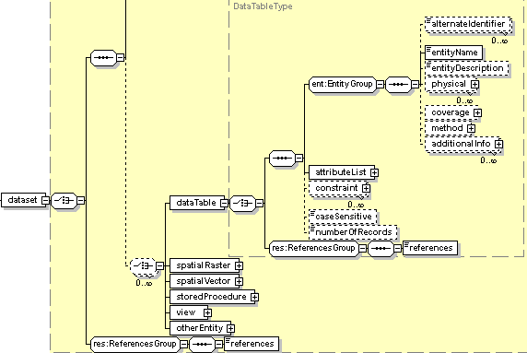

The elements must be entered in the sequence shown in Figure 6, and any element that was specified in the ResourceGroup applies to the entire dataset that is being documented. This is especially significant if the dataset has more than one data entity. For example, assume the dataset consists of three files: Climate.xls, Biodiversity.xls, and Productivity.xls. In this case, ResourceGroup elements such as <distribution> or <coverage> must be general enough to apply to all of the files. This would be true also if Climate.xls, Biodiversity.xls, and Productivity.xls were the names of tables in a database.

Metalog 2

Q:If you are documenting a dataset aren’t you documenting just one thing?

A: Not necessarily. Remember that, “In EML, the term dataset refers to one or more data entities.” There is no generally accepted practice on what to include in an EML dataset document. Some people will choose to have a one-to-one correspondence between an EML document and a data entity and a single physical file. Others will document several data entities in one dataset document.

Say that you go out in the field once a month for a year with a notebook,and a number of different things, including the temperature and other climate attributes, measurements of primary productivity and do species counts, etc.. When you get back to the lab, you open up a spreadsheet program and enter the climate information in climate.xls, record the species counts in biodiversity.xls, and finally enter the productivity information in productivity.xls.

Eco Informatics: Let me interrupt for a moment. It is important to recognize that there is a distinction between physical files and data entities. A data entity is a logical category. Let me show you what I mean. Suppose that there are five data attributes: LocationCode, Temperature, Rainfall, Productivity_Index, and Biodiversity_Index. In Example One, all five attributes are in a single table. In this example there is a one-to-one relationship between the data entity and the physical file. In Example Two, the attributes have been broken up into different tables: a table for the climate data, a table for the productivity data, and a third table for the biodiversity data. However, each of these tables has been included in a single Excel file. There is no magic to this being an Excel file; the tables could just as easily be stored sequentially in a simple text file. In this case there are three data entities (logical) in one file (physical). In Example Three, each table has been saved in a different physical file. Once again there is a one-to-one relationship between data entities and physical files.

emlMaven: So, if you choose to organize your data as in examples two or three, then you have a data set that consists of three table entities, each containing several data attributes.

Pat: Okay, I understand. But what I’m really interested in is providing data that will be useful to other ecologists working on similar projects.

emlMaven: Then you’re in luck. The EML schema of data entities and attributes includes all kinds of opportunities for defining and describing your research projects, from the actual physical file to the distribution of the research to the geographic and taxonomic areas that the research covers. But for that, we’ll need to see the modules in action.

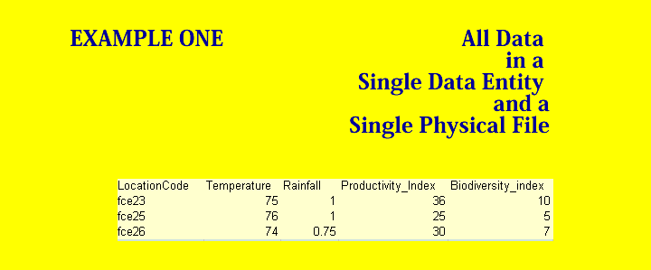

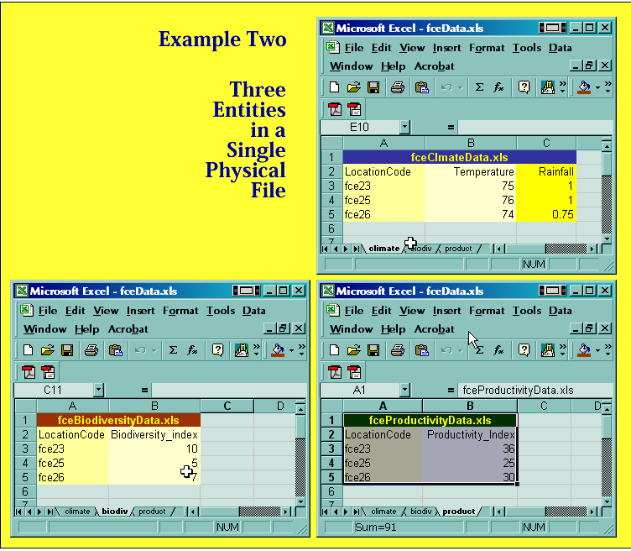
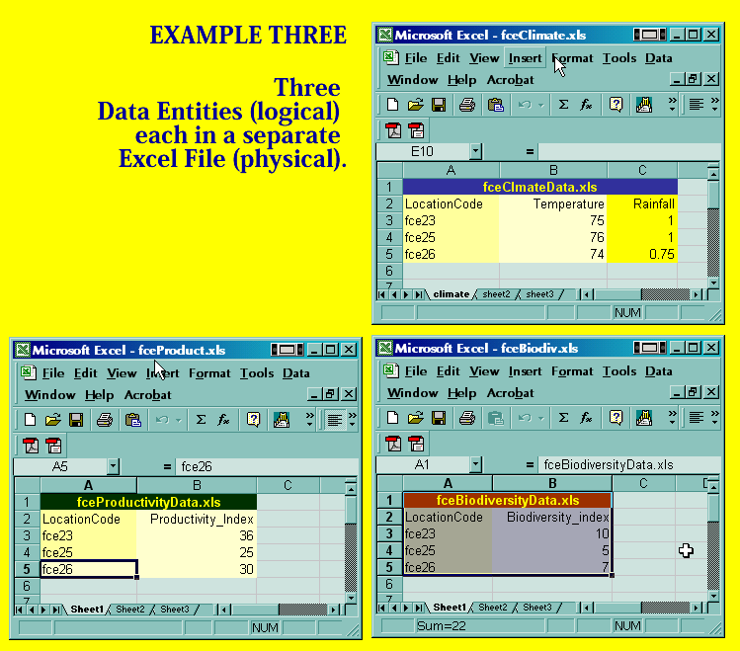

Entity and attribute

A look at the expanded schema in Figure 7 reveals the hierarchy of entity to attribute and illustrates that each attribute must correspond to a previously defined entity.

Figure 7
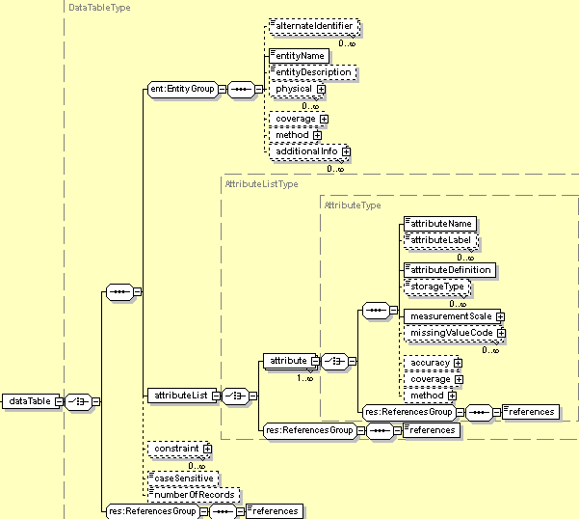

In terms of actual code, the entity-attribute hierarchy would translate into something like this:

<dataTable>
<entityName>Groundwater Level</entityName>
<entityDescription>Groundwater levels in sample wells</entityDescription>
<attributeList>
<attribute>
<attributeName>SAMPLEDATE</attributeName>
<attributeDefinition>date sample was taken</attributeDefinition>
<measurementScale>
<datetime>
<formatString>YYYY-MM-DD</formatString>
<dateTimePrecision>1</dateTimePrecision>
<dateTimeDomain>
<bounds>
<minimum exclusive="false">1989-01-01</minimum>
<maximum exclusive="false">2050-12-31</maximum>
</bounds>
</dateTimeDomain>
</datetime>
</measurementScale>
</attribute>
<attribute>
<attributeName>WELLID</attributeName>
<attributeDefinition>well location identification code</attributeDefinition>
<measurementScale>
<nominal>
<nonNumericDomain>
<enumeratedDomain>
<codeDefinition>
<code>K1</code>
<definition> Well at location K1</definition>
</codeDefinition>
</enumeratedDomain>
</nonNumericDomain>
</nominal>
</measurementScale>
</attribute>
<attribute>
<attributeName>WELL_LEVEL</attributeName>
<attributeDefinition>water level above the datum</attributeDefinition>
<measurementScale>
<ratio>
<unit>
<standardUnit>meter</standardUnit>
</unit>
<precision>0.01</precision>
<numericDomain>
<numberType>real</numberType>
<bounds>
<minimum exclusive="false">0.0</minimum>
<maximum exclusive="false">700.0</maximum>
</bounds>
</numericDomain>
</ratio>
</measurementScale>
</attribute>
</attributeList>
<numberOfRecords>2602</numberOfRecords>
</dataTable>
</dataset>

In this example, there is one entity named “Groundwater Level” and three attributes, “SAMPLEDATE,” “WELLID,” and “WELL_LEVEL.” The entire list of attributes is enclosed in the <attributeList></attributeList> tagset, but each attribute is part of the overall entity, which, in this case, is stored in a single physical file. This file has been written to return data in a format such as the one shown in Table 2 when used in conjunction with a search program.

Table 2
SAMPLEDATE | WELLID | WELL_LEVEL
03/04/1997 | K1 | 501.93
04/12/1997 | K1 | 501.99
03/04/1997 | K2 | 501.51
04/12/1997 | K2 | 501.69
03/04/1997 | K5 | 500.92
04/12/1997 | K5 | 500.99
03/04/1997 | K9 | 500.48

Inside the data attribute

The actual data contained in the individual cells of these tables generally is not defined in the metadata document, because the primary purpose of the metadata is to provide the additional context and information necessary to effectively interpret the data. The information contained within each attribute element offers a description of the type of data contained within that attribute. For example, the following section of the previous code describes how the SAMPLEDATE column is formatted, using the required attribute fields: <attributeName>, <attributeDefinition>, and <measurementScale>.

<attributeList>
<attribute>
<attributeName>SAMPLEDATE</attributeName>
<attributeDefinition>date sample was taken</attributeDefinition>
<measurementScale>
<datetime>
<formatString>YYYY-MM-DD</formatString>
<dateTimePrecision>1</dateTimePrecision>
<dateTimeDomain>
<bounds>
<minimum exclusive="false">1989-01-01</minimum>
<maximum exclusive="false">2050-12-31</maximum>
</bounds>
</dateTimeDomain>
</datetime>
</measurementScale>
</attribute>
<attribute>

The fields covering the attribute’s name and definition are fairly self-explanatory, however, the <measurementScale> field warrants further explanation.

Figure 8
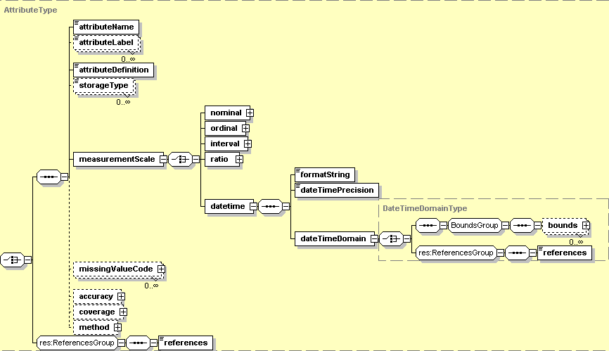

The <measurementScale> tagset is required, and it is a bit more complicated as it contains several required fields within it. First, the type of <measurementScale> must be selected, be it <nominal>, <ordinal>, <interval>, <ratio>, or <datetime> (see Figure 8). In the short EML fragment above, the selected scale is <datetime>.
For a complete listing of the ISO 8601 preferred date time formats, go to: http://www.iso.org/iso/en/prods-services/popstds/
datesandtime.html#three

One of the required elements in <datetime> consists of the <formatString>, which specifies the format of the date to be returned; here it is in the “YYYY-MM-DD” format. The <dateTimePrecision> tagset defines the smallest unit represented by the <formatString>. In this example, the “1” value means that the dates are precise to the nearest day. If it is necessary to have a format string that is more precise, let’s say to the nearest tenth of a second, the <formatString> “hh:mm:ss.ss” would then have a <dateTimePrecision> of 0.1, that is, to the nearest tenth. For most values expressed in days, however, the precision value will be “1.”

The exception to this rule occurs when the <datetime> originates from a file that automatically adds values for hours, minutes and seconds to the simple YYYY-MM-DD format. Some types of software, such as Microsoft Access, will automatically do this, adding 00:00:00 to the date when no values for hours, minutes or seconds have actually been specified by the person entering the data. In this instance, the <dateTimePrecision> will need to be entered as “86400,” (60 sec. X 60 min. X 24 hours) which is the value that seconds must be multiplied by in order to convert them to days and return a value with the correct precision.

The <dateTimeDomain> then specifies the <bounds> of the dates that are valid to be returned for a particular attribute. In this case, no dates will be returned that are earlier than January 1, 1989 or later than December 31, 2050.

A closer look at the other two attributes, WELLID and WELL_LEVEL, provides examples of the <nominal> and <ratio> measurement scales.

<attribute>
<attributeName>WELLID</attributeName>
<attributeDefinition>well location identification code</attributeDefinition>
<measurementScale>
<nominal>
<nonNumericDomain>
<enumeratedDomain>
<codeDefinition>
<code>K1</code>
<definition>Well at Tyler Creek station</definition>
</codeDefinition>
</enumeratedDomain>
</nonNumericDomain>
</nominal>
</measurementScale>
</attribute>
<attribute>
<attributeName>WELL_LEVEL</attributeName>
<attributeDefinition>water level above the datum</attributeDefinition>
<measurementScale>
<ratio>
<unit>
<standardUnit>meter</standardUnit>
</unit>
<precision>0.01</precision>
<numericDomain>
<numberType>real</numberType>
<bounds>
<minimum exclusive="false">0.0</minimum>
<maximum exclusive="false">700.0</maximum>
</bounds>
</numericDomain>
</ratio>
</measurementScale>
</attribute>

The <nominal> scale is used when data is being labeled without any quantitative implications, such as in the WELL ID’s of “K1,” “K2,” etc. The <nominal> value is further specified as a <nonNumericDomain>, which can be either a <textDomain> or an <enumeratedDomain>, as seen in Figure 9. A <textDomain> only requires a textual <definition> to be complete, but in this case we have an <enumeratedDomain> with a <codeDefinition> consisting of the <code> “K1” and the <definition> “Well at Tyler Creek station”.

Figure 9
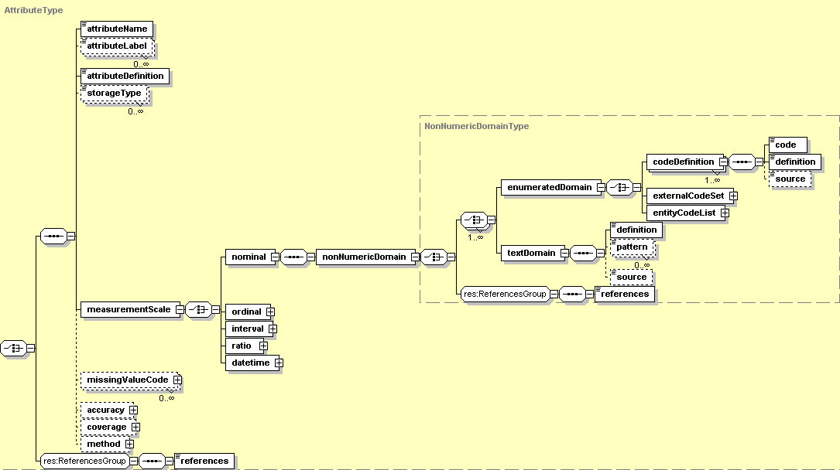

Other choices of <enumeratedDomain> include <externalCodeSet> and <entityCodeList>. The <externalCodeSet> would be chosen when the code set being used exists in a separate document, and would be defined with a <codesetName>, a <citation>, or a <codesetURL>. The <entityCodeList> consists of a choice of <entityReference>, <valueAttributeReference>, and <definitionAttributeReference>, and is used to reference a code set that already exists in some part of the dataset.

The <ordinal> scale has essentially the same schema as the <nominal> in terms of EML code, although it would be used when the coded values are part of a ranked scale with some quantitative, but non-arithmetic value, such as “1=poor water quality,” “2=fair water quality,” etc. Ordinal scale data can be rank ordered, to the extent of determining “less than” and “greater than” sequences, but without information about the size of the intervals separating any two entries.

The WELL_LEVEL attribute is defined on the <ratio> measurement scale, however, which differs from the <nominal> and <ordinal> in that the measurements it describes correspond to a real numeric scale that has an actual zero point. Here, the water is being measured at some height relative to 0 meters, so the actual numbers returned would be a ratio. This <ratio> scale also would work for measurements such as degrees Kelvin or the weight of the biomass in a lake.

Required elements for the <ratio> scale include <unit>, <precision>, and <numericDomain> (see Figure 10). The <unit> tag specifies the units being used, in this example the <standardUnit> of a meter. The very useful <customUnit> is also available, which can be used to define very specific non-standard units, such as “milligramsPerSquareMeterPerDay.” The <precision> is similar to the <dateTimePrecision> in that it is used to specify the precision of the units being used, such as one hundredth of a meter “0.01” in this example.

Figure 10
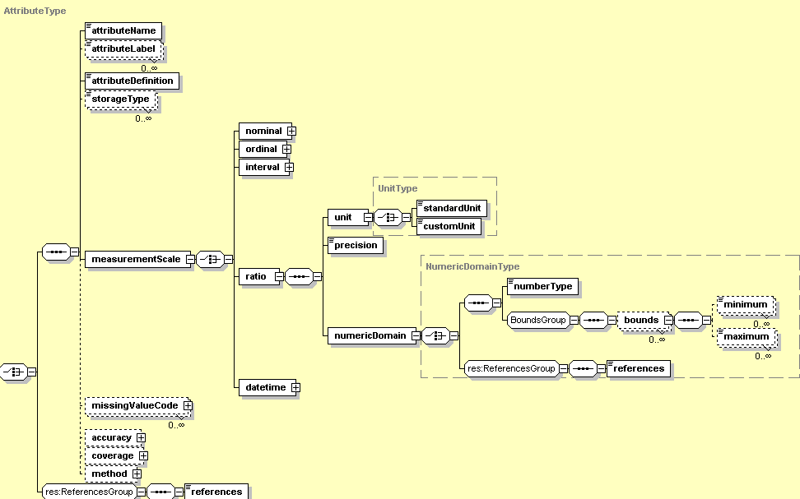

The <numericDomain> is a small module that requires a <numberType>, which can be “real,” as in this example, or “natural,” “whole,” or “integer.” All numbers that contain fractional or decimal elements would be described as real, while all non-fractional positive or negative numbers are integers, and whole numbers consist only of positive integers. Natural numbers are all of the whole numbers except zero. When defining a <numberType>, the most restrictive description of the numbers used should be given. For a more in depth discussion of number types, go to http://www.purplemath.com/modules/numtypes.htm or see Table 3 below.

Table 3: Number Types
NATURAL | WHOLE | INTEGER | REAL
1 | 1 | 1 | 1
4 | 4 | 4 | 4
23 | 23 | 23 | 0
10 | 10 | 0 | -24
75 | 0 | -24 | -735.26

The <bounds>, while not required, can then used to specify the <minimum> and <maximum> possible values for a particular attribute. These are helpful to prevent obviously wrong values from being included in the data. In this example, unacceptable values are any values less than 0 or higher than 700. You may notice that the schema does not specifically require either minimum or maximum <bounds>. This is because the <bounds> are meant to represent the logically possible range of values and not the actual range of values found in the data. For a well of 700 meters, water levels could logically range from 0-700, but a variable such as water temperature on the Celsius scale could only have the logical range of 0-100, as any value less than 0 would be defined as ice and any value greater than 100 would be defined as water vapor. In certain instances, there may not be a logical minimum or maximum, and so either one or both of those tags could be left out of the <bounds> definition. This is especially useful if the <maximum> bound is unknown or infinite.

The <interval> scale contains all the same elements as the <ratio> scale, the only difference being that it is used for measurements that do not have an absolute zero value, such as the Celsius or Fahrenheit temperature scales. Measures taken on an interval scale typically cannot be compared as ratios—e.g., you cannot say that raising a temperature of 10 degrees F to 20 degrees F is a “doubling” of the temperature.

Data description on different levels

Most metadata-defining EML documents need not be extensive; it is up to the individual metadata provider to decide how much description he or she wants to include. As a general rule, however, the more description that can be provided, the better, and the structure of EML provides many opportunities to describe the data being presented. Descriptions of data can be provided on the dataset level, the entity level, or the attribute level, depending on how broadly those descriptions apply to the documented research.

For example, between the <entity> and <attribute> levels in the EML schema, there is an optional module that begins and ends with the <physical></physical> tagset (see Figure 11 for this schema).

This tagset, while not required, is helpful in that it defines the physical aspects of the actual data file that the entity and attribute metadata describes. The <physical> module requires both an <objectName>, which is the actual name of the physical data file, (“limnprpr.dat” in this example), and a <dataFormat>, which describes the way in which the data is organized in that file. There are several choices of <dataFormat> available in the EML schema: <textFormat>, <externallyDefinedFormat>, or <binaryRasterFormat>.

Figure 11
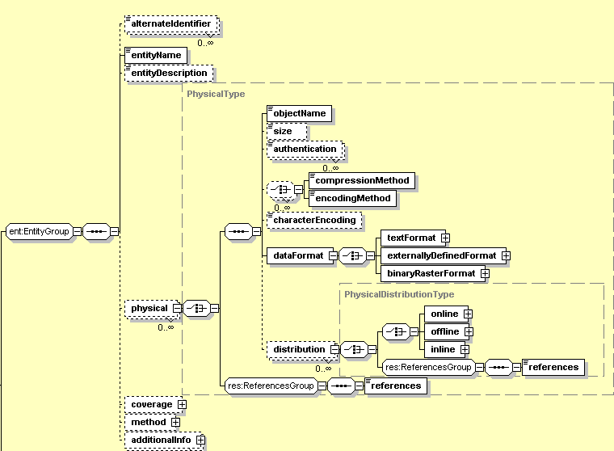

Of these, the <textFormat> and <externallyDefined Format> are the most straightforward, and will be discussed briefly. The <binaryRasterFormat> is for use with GIS data and is more complex. Researchers who are interested in defining <binaryRasterFormat> for EML should refer to the technical specifications manual.

<physical>
<objectName>limnprpr.dat</objectName>
<dataFormat>
<textFormat>
<attributeOrientation>column</attributeOrientation>
<simpleDelimited>
<fieldDelimiter>,</fieldDelimiter>
</simpleDelimited>
</textFormat>
</dataFormat>
<distribution>
<online>
<url function="information">http://huey.colorado.edu/LTER/datasets/lakes/lakebio/limnprpr.dat</url>
</online>
</distribution>
</physical>

The above EML fragment sample uses a <textFormat>, which merely requires an <attributeOrientation>, either a “column” or a “row,” and a mention of how the fields between each row or column are delimited. The <textFormat> offers a choice of <simpleDelimited> or <complex>. The <simpleDelimited> choice only requires a <fieldDelimiter>, which in our example is a comma “,” the simplest field delimiter. The <complex> delimiters require further information that again can be found in the technical specifications manual for those who are interested in data file minutiae. The <externallyDefinedFormat> only requires a <formatName>, such as “Excel 97” or “Access 2000,” which refers the user to an outside file as the template for the data format.

Following the <dataFormat> is a tagset called <distribution>, which warrants further explanation. The <distribution> describes where the actual data being described can be found, either in <online> or <offline> source material. The <online> tag allows a metadata provider to specify a <url> where the data may be accessed, while the <offline> tag offers choices of the name, volume, and format of the medium where the data can be found. In this example, the data is located in an <online> file located at http://huey.colorado.edu/LTER/datasets/lakes/lakebio/limnprpr.dat. An additional <inline> tag may be used to specify the data within the metadata file, and it is being further developed for EML usage.

The entire <physical> tagset is important in that it is an example of a description that is being defined at the entity level. That is, the <objectName> and <distribution> now apply to all of the attributes within that entity. If one were then to refer to a different file in a different location, a new <entity> containing a new <physical> description and distribution would need to be defined.

The tricky part is that <distribution> may also be defined earlier, within the ResourceGroup module. If one were to define <distribution> in this earlier module, the <online> or <offline> location specified would then apply to the entire <dataset>, not just one <dataTable> entity.

This is even more important with the <coverage> module, which may be defined at the <dataset>, <entity>, or <attribute> level. Coverage is broken down into <geographicCoverage>, <temporalCoverage>, and <taxonomicCoverage> (see Figure 12). The <geographicCoverage> tagset requires a <geographicDescription> and a set of <boundingCoordinates>, both of which provide information about the area being studied. The timeframe of the study can be described using <temporalCoverage>, which offers a choice of a <singleDateTime> or a <rangeofDates>. For <taxonomicCoverage>, all that is required is a <taxonomicClassification>. It is up to the metadata provider to decide what type of coverage, if any, is appropriate for each level of metadata; that is, whether the coverage applies to an entire dataset, or just to one specific entity or attribute.

Figure 12
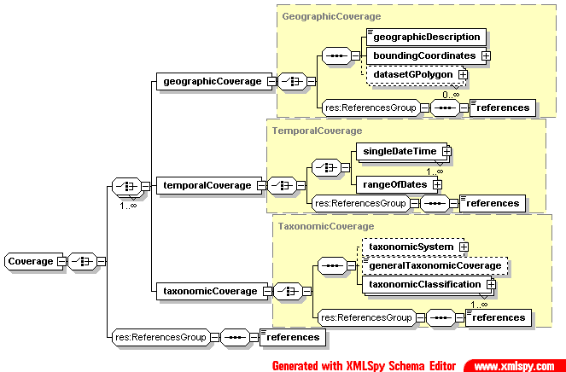

Metalog 3

Pat: Okay, so let’s say my study covers several Peromyscus species and their relationship to piñon and juniper forest ecosystems. A description of this coverage would be really helpful to include in my metadata. How would I go about coding it into EML?

emlMaven: Well, first you need to decide what level you want to define the data for.

Pat: Based on what we’ve discussed so far, I think it would be on the entity level. This study continued over three different summers, so there are three actual data files containing my findings during each time frame. Within each of these files are my species counts for each trapping location, as well as information about pinon and juniper biomass.

Eco Informatics: Based on what you just described, I’d say you were correct in your estimation of the metadata levels. Defining your coverage at the dataset level would be too broad, since there are several different sets of <temporalCoverage>. Each one would need to be defined as a separate entity. What about your locations? Was the <geographicCoverage> the same each summer?

Pat: Yes, I used the same trapping locations each year, and I covered the same species.

emlMaven: Then you have three different choices of how to integrate this coverage into your metadata: You could define the taxonomic and geographic coverage at the dataset level and then define temporal coverage at each of the entity levels; you could simply repeat the same geographic and taxonomic coverage information for each entity, changing the temporal coverage each time; or, instead of repeating the geographic and taxonomic coverage for each entity, you could define them only once and then use EML references.

Pat: Which option do you recommend?

Eco Informatics: Well, defining the taxonomic and geographic coverage at the dataset level may look easier and faster, but it is going to make processing the information more difficult for database software and require more complicated logic to interpret. Repeating the information for each entity is the most straightforward, and the one to one correspondence between entity and coverage makes it easier for database software to interpret the EML fragment. The third option, using references, is probably the most elegant, in that it cuts down on the amount of repetition at the EML level but does not require significantly more code to display at the software level.

Pat: Are references difficult to do?

emlMaven: Not at all. As we go through the EML coverage module, we’ll see just how simple they are to use and apply to many areas of your metadata.

Using coverage to describe data

The coverage module utilizes the same format no matter what level it is located on within the dataset. There is a choice among <geographicCoverage>, <temporalCoverage>, and/or <taxonomicCoverage> within each module, but all three are not required at a single level. Theoretically, this means that <geographicCoverage> could be defined at the dataset level, while <temporalCoverage> could be defined at the entity level, and <taxonomicCoverage> could be specified at the <attribute> level. Most likely, though, at least two of the three coverage elements will be defined at the same level.

An EML fragment that describes all three types of coverage at the entity level is shown below:

<dataTable>
<entityName>Rodents of the Southwest Summer 1999</entityName>
<entityDescription>Rodent species in central New Mexico and their relationship to pinon and juniper forest</entityDescription>
<coverage>
<geographicCoverage>
<geographicDescription>northeast section of Sevilleta National Wildlife Refuge, near Socorro, New Mexico</geographicDescription>
<boundingCoordinates>
<westBoundingCoordinate>106.689<westBoundingCoordinate>
<eastBoundingCoordinate>106.522<eastBoundingCoordinate>
<northBoundingCoordinate>34.408<northBoundingCoordinate>
<southBoundingCoordinate>34.305<southBoundingCoordinate>
</boundingCoordinates>
</geographicCoverage>
<temporalCoverage>
<rangeOfDates>
<beginDate>
<calendarDate>1999-05-23</calendarDate>
</beginDate>
<endDate>
<calendarDate>1999-08-15</calendarDate>
</endDate>
</rangeOfDates>
</temporalCoverage>
<taxonomicCoverage>
<taxonomicClassification>
<taxonRankName>genus</taxonRankName>
<taxonRankValue>Peromyscus</taxonRankValue>
<commonName>deer mice, white-footed mice</commonName
<taxonomicClassification>
<taxonRankName>species</taxonRankName>
<taxonRankValue>Peromyscus maniculatus</taxonRankValue>
<commonName>deer mouse</commonName>
</taxonomicClassification>
<taxonomicClassification>
<taxonRankName>species</taxonRankName>
<taxonRankValue>Peromyscus boylii</taxonRankValue>
<commonName>brush mouse</commonName>
</taxonomicClassification>
<taxonomicClassification>
<taxonRankName>species</taxonRankName>
<taxonRankValue>Peromyscus difficilis </taxonRankValue>
<commonName>rock mouse</commonName>
</taxonomicClassification>
<taxonomicClassification>
<taxonRankName>species</taxonRankName>
<taxonRankValue>Peromyscus eremicus </taxonRankValue>
<commonName>cactus mouse</commonName>
</taxonomicClassification>
<taxonomicClassification>
<taxonRankName>species</taxonRankName>
<taxonRankValue>Peromyscus leucopus</taxonRankValue>
<commonName>white-footed mouse</commonName>
</taxonomicClassification>
<taxonomicClassification>
<taxonRankName>species</taxonRankName>
<taxonRankValue>Peromyscus truei</taxonRankValue>
<commonName>pinon mouse</commonName>
</taxonomicClassification>
</taxonomicClassification>
</taxonomicCoverage>
</coverage>
<attributeList>
<attribute>…

Here, <coverage> is located after the <entityName> and <entityDescription> have been defined, but before the attributes are listed. The <geographicCoverage> is listed first, and it requires a <geographicDescription>, with a sentence or two describing the general area of the study, and a set of <boundingCoordinates>, which use latitude and longitude values at the east, west, north and south boundaries to block off a rough rectangular area within which the research was located. Metadata providers should note that the original EML technical specifications require values in decimal degrees rather than the standard degrees, minutes, and seconds for latitude and longitude. Decimal degree values can be easily obtained using an online converter such as the one located at http://www.beg.utexas.edu/GIS/tools/DMS_DD.htm, which also performs conversions back from decimal degrees to degrees, minutes, and seconds.

The <temporalCoverage> offers the choice of <singleDateTime> or <rangeOfDates>, both of which require a <calendarDate> in a simple YYYY-MM-DD format. The <rangeOfDates> option requires both a <beginDate> and an <endDate>, as shown in the above example.

The <taxonomicCoverage> requires a <taxonomicClassificiation>, which consists of a <taxonRankName> indicating the taxonomic level that is being defined, in this case “genus,” and a <taxonRankValue>, which is the actual name of the genus, “Peromyscus.” The <commonName> (or names, if there are several) can also be included. The structure of the <taxonomicCoverage> module also allows for nesting of listings, such as in the above example, where the <taxonRankValue> and <commonName> of each separate species in the study is then listed individually in its own <taxonomicClassification> within the larger classification. This can be done at every level, beginning with Kingdom, and defining the rank and value for each.

References vs. repetition

The previous EML fragment presents all three types of <coverage> defined at the level of a single entity. This type of structure is perfectly suited for the dataset that contains only one entity and several attributes, all of which cover the same material. When there are several entities that share some of the same coverage elements, however, as in the example described in Metalog 3, you may not want to repeat the same coverage information several times as it can become unwieldy in the EML code.

While you could define some types of coverage at the dataset level and others at the entity level, the best way to handle this situation is to use EML references within the entities.

By this method, you can define all the coverage elements within the first entity to which they apply and then, instead of repeating the information, use references in the following entities to note coverage information that is the same.

Let’s say that the EML fragment above represents the first of three entities for which you are defining coverage. The <geographicCoverage> and <taxonomicCoverage> are the same for all three entities; it is only the <temporalCoverage> that changes. The only change you would need to make to the above code would be to define an ID for both geographic and taxonomic coverage in the following format:

<geographicCoverage id=”sevill.1”>
<geographicDescription>northeast section of Sevilleta National Wildlife Refuge, near Socorro, New Mexico</geographicDescription>
<boundingCoordinates>
<westBoundingCoordinate>106.689<westBoundingCoordinate>
<eastBoundingCoordinate>106.522<eastBoundingCoordinate>
<northBoundingCoordinate>34.408<northBoundingCoordinate>
<southBoundingCoordinate>34.305<southBoundingCoordinate>
</boundingCoordinates>
</geographicCoverage>

The only difference is that instead of using the tag <geographicCoverage> to open your definition of that element in the first entity, you would use <geographicCoverage id=”xxx”>, with the ID name you are giving to your reference included within the quotation marks. If you then opened taxonomic coverage with <taxonomicCoverage id=”peromys.1”>, the next two entities would then have coverage defined like this:

Second Entity
…<dataTable>
<entityName>Rodents of the Southwest Summer 2000</entityName>
<entityDescription>Rodent species in central New Mexico and their relationship to pinon and juniper forest</entityDescription>
<coverage>
<geographicCoverage>
<references>sevill.1</references>
</geographicCoverage>
<temporalCoverage>
<rangeOfDates>
<beginDate>
<calendarDate>2000-05-18</calendarDate>
</beginDate>
<endDate>
<calendarDate>2000-08-22</calendarDate>
</endDate>
</rangeOfDates>
</temporalCoverage>
<taxonomicCoverage>
<references>peromys.1</references>
</taxonomicCoverage>
</coverage>
<attributeList>
<attribute>…

Third Entity
…<dataTable>
<entityName>Rodents of the Southwest Summer 2001</entityName>
<entityDescription>Rodent species in central New Mexico and their relationship to pinon and juniper forest</entityDescription>
<coverage>
<geographicCoverage>
<references>sevill.1</references>
</geographicCoverage>
<temporalCoverage>
<rangeOfDates>
<beginDate>
<calendarDate>2001-05-31</calendarDate>
</beginDate>
<endDate>
<calendarDate>2001-08-28</calendarDate>
</endDate>
</rangeOfDates>
</temporalCoverage>
<taxonomicCoverage>
<references>peromys.1</references>
</taxonomicCoverage>
</coverage>
<attributeList>
<attribute>…

The reference module is not confined to the sole purpose of defining coverage elements. References can be used with almost any EML element that will be referred to later in the dataset. For example, if your <creator> and <contact> were the same person, you could use the tag <creator id=”pat.eco23”> to open your creator description and then simply refer to your contact information as

<contact>
<references>pat.eco23</references>
</contact>

This technique will also work within and among attributes if you have several entities that share certain attributes in common, with any of the <physical> file descriptors, or with <citation>, which is another important module that will be defined shortly.

Metalog 4

Pat: I was just going to ask about that. Citations are important to provide for any other ecologist looking at my metadata. So are my methods, for that matter. Can I use references with those, too?

emlMaven: References can be used with most modules, but at this time they are not designed for use with the methods module. The idea is that method entries are generally unique. In most cases, your methods will either apply to your entire dataset, or only to a single entity or attribute within your dataset. If your methods apply to multiple entries, then you can just place your <methods> descriptions at the dataset level, where they will apply to all entities and attributes. If it’s a standardized method that you want to reference, then you can publish it as a <protocol> instead. Protocols are located within the methods module on each level of the dataset, and the protocol module does include references.

Pat: Aren’t protocols and methods essentially the same thing?

Eco Informatics: Not necessarily. In EML, a protocol is a procedure that prescribes a standardized method, while a method refers to a method that was actually performed in the process of acquiring the data. A method describes what the researcher or research team did, such as “We trapped rodents at these five locations using Sherman live traps.” Protocols would refer to a set standard such as instructions for using the traps and are more imperative in nature, such as “Bait the trap using 3 oz. of steamed, crimped oats.”

emlMaven: That is why protocols are located in the <methods> modules. In the course of describing your own methods for acquiring data, you may call on or reference previously published protocols that do not come from your own data. Citations are also located within the methods module, so we can examine all three of these elements at once.

Knowing the details: Methods, protocols, and citations

The <methods> module is located in the EML schema just below <contact> on the dataset level, and also within the EntityGroup and the <attribute> module. There are three element choices within this module, consisting of <methodStep>, <sampling>, and <qualityControl>. The first and most common type of method is the required <methodStep>, which contains a variety of elements that assist in describing procedures.

The only required element within the <methodStep> is a <description>. This <description> is simply written in paragraph format and is enclosed in the <para></para> tagset, except in cases where it is long enough to require the additional <section></section> tagset as well. There is a choice of formatting within the <para></para> tagset that, while not required, can be useful if the method description is written in list format rather than simple paragraph format.

Formatting choices within <para></para> include <itemizedlist>, <orderedlist>, <emphasis>, <subscript>, <superscript>, and <literalLayout>. Most of these markup tags are fairly self-explanatory, although it should be mentioned that <itemizedlist> is for use with bulleted lists, while <orderedlist> corresponds to numbered lists. The <literalLayout> element is one that specifies that none of the text structure (whitespace) within the tagset should be altered.

If a <methodStep> description is to be organized into an itemized list, the entire list should be enclosed in the <itemizedlist> tagset, with each separate item as its own <listitem> entry, which, in turn, has its own <para></para> tagset within it. The EML schema for this is shown in Figure 13.

Figure 13
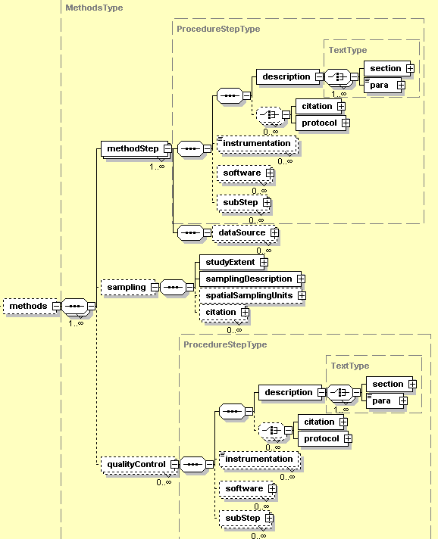
An EML <methodStep> code fragment would look something like this:

<method>
<methodStep>
<description>
<para>
<itemizedlist>
<listitem>
<para>Traps were set at a locality for four trap-nights.</para>
</listitem>
<listitem>
<para> Each trap was baited with a handful of steamed, crimped oats tossed into the trap after it was placed on the ground; a few oats were left outside the trap entrance to entice passers-by.</para>
</listitem>
<listitem>
<para> During expectedly cold nights, and during all of the fall period, a handful of cotton batting was also placed to the rear of each trap to help keep captures warm overnight.</para>
</listitem>
</itemizedlist>
</para>
</section>
</description>
</methodStep>
</method>

When used with an xsl script, the above EML fragment would return a list with a format that looks like this:

- Traps were set at a locality for four trap-nights.
- Each trap was baited with a handful of steamed, crimped oats tossed into the trap after it is placed on the ground; a few oats were left outside the trap entrance to entice passers-by.
- During expectedly cold nights, and during all of the fall period, a handful of cotton batting was also placed to the rear of each trap to help keep captures warm overnight.

Aside from the <description>, <methodStep> also includes an optional choice of using the <citation> and <protocol> modules to reference additional information.

When expanded, the <citation> module opens into two separate sections (see Figure 14), one of which is the ResourceGroup module described on page 7. Elements from the ResourceGroup module that would be used with most citations include <title>, <creator> (author), and <pubDate>, while the second section provides the means to describe the type of work that is being cited.

There is a large selection of citation types available, from <article>, <book>, <editedBook>, and <manuscript> elements to <conferenceProceedings>, <personalCommunication>, and <audioVisual> materials, each of which contain any number of required and optional descriptors. Most of these elements are very straightforward, such as those within <book>, which contains the required set of elements: <publisher><organizationName></organizationName><publisher>. Other optional, but helpful, elements within <book> include <publicationPlace>, <edition>, and <volume>.

Likewise, <article> requires the elements <journal>, <volume>, and <pageRange>, while <issue>, <publisher>, <publicationPlace>, and <ISSN> are optional.

Figure 14
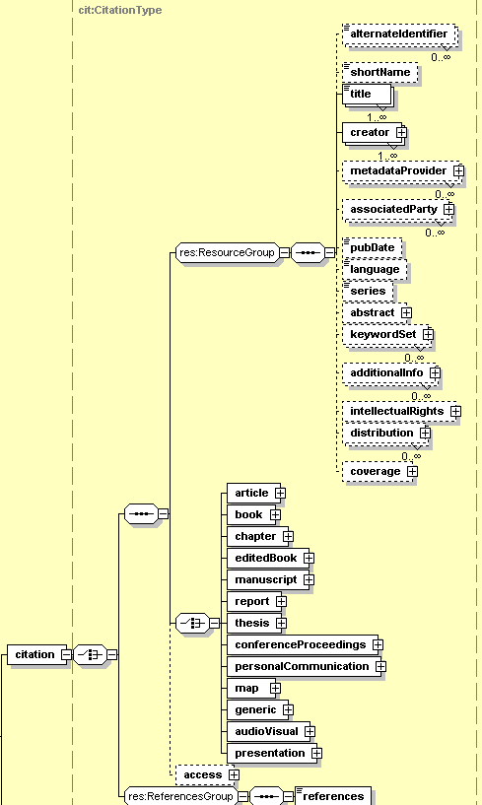

It would be somewhat excessive to describe every element within each citation component, as most of them are descriptive enough not to need detailed explanation. For those elements that are not self-explanatory, a complete breakdown of the <citation> schema and its various components is available in the EML technical specifications manual (see Appendix XX).

The important thing to remember about the <citation> module as a whole is that any ResourceGroup elements used in the citation description must be defined first, before the actual citation type is defined. An EML fragment for a typical <book> type of citation would resemble the following example:

<citation>
<title>Limnological Methods</title>
<creator>
<individualName>
<givenName>R.G.</givenName>
<surName>Wetzel</surName>
</individualName>
</creator>
<creator>
<individualName>
<givenName>G.E.</givenName>
<surName>Likens</surName>
</individualName>
</creator>
<pubDate>1979</pubDate>
<book>
<publisher>
<organizationName>Saunders</organizationName>
</publisher>
<publicationPlace>Philadelphia</publicationPlace>
</book>
</citation>

Notice that the title, name and publication date elements all occur in the EML code before the <book> type is specified, along with the <book> elements of <publisher>, <organizationName>, and <publicationPlace>. This hierarchy within the <citation> module is the same for all elements within it, and it occurs in the same form wherever the <citation> module is found within the larger EML structure.

The <protocol> module follows <citation> within <methodStep>, although it too is found in various other places within the EML structure. As discussed earlier, <protocol> is designed for use with standardized series of instructions, especially those that are referenced from outside the particular dataset in which they occur.

Like <citation>, <protocol> also expands into the ResourceGroup module, allowing the <title> and <creator> of the protocol to be identified (see Figure 15). The <protocol> module also contains an optional <proceduralStep> element, which requires a <description> in the aforementioned <para></para> format of the standardized procedure being described, and an optional <access> component in the same form as the one described on page 11.

Figure 15
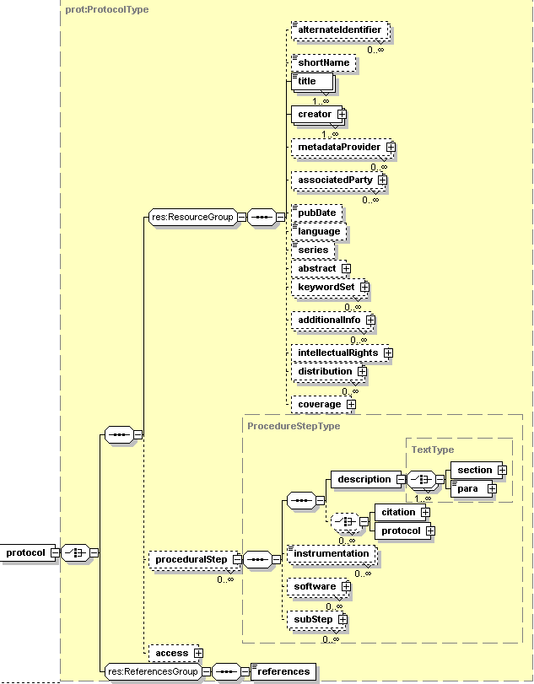

Returning now to the remainder of the elements within <methodStep>, there are several optional elements located after the <protocol> module (see Figure 13). These include <instrumentation>, <software>, and <subStep>, as well as <dataSource>.

The <instrumentation> element provides space to describe any instruments that were used in the process of acquiring data, such as “Sherman live trap” or “Turner Designs 10-Au-005-CE fluorometer.” There are no additional description tags within the element, so <instrumentation>Sherman live trap</instrumentation> would be all that is required.

The <software> module is for use mainly with custom software that may have been used in the process of documenting the dataset. It is not meant for use in describing commercial applications, such as Excel or Access, and will most likely not be used by the average researcher during metadata documentation. The technical specifications manual will provide an explanation for those who wish to explore this module further.

A <subStep> contains the same format as its parent element <methodStep>, and would only be used when a minute breakdown of the method steps is necessary. The <dataSource> element has the same format as the larger <dataset> module, including entities, attributes and everything in between. This element would only be used when the submitted data is based on synthetic research drawn from several external datasets, and it allows these separate datasets to then be documented individually within the larger context of the new, synthesized dataset.

The two remaining <methods> elements we will discuss are the optional <sampling> and <qualityControl>, both of which provide more detailed information about study procedures. Within <sampling> are the required elements <studyExtent> and <samplingDescription>, and the optional <spatialSamplingUnits>, as well as another optional <citation> module. Most of these units are composed of elements that we have seen before; it is only their direct relationship to explicit sampling methods that is slightly different.

For example, <studyExtent> offers a choice of the two familiar elements of <coverage> and <description>, which are to be used to specify both the sampling area and the sampling frequency. As there is a choice of descriptors, either the <coverage> module, with full geographic, temporal and taxonomic coverage can be used, or the extent of the study can be described simply in <para></para> format under <description>. Note that <coverage> can also be referenced from an earlier <coverage> module if so desired.

The <samplingDescription> element is also presented in simple paragraph format, and is designed for describing exact sampling methods being used in the course of a research study.

The <spatialSamplingUnits> refer to specific geographical areas that are being sampled. Once again, the <coverage> module comes in handy for describing these areas; although in this instance the <coverage> module only contains <geographicCoverage> elements. A <referencedEntityId> option is also available, which operates like a regular reference, except that it refers to the “id” of a specific entity in which the metadata for the dataset that contains the actual geographic reference values is located.

The final <methods> element is <qualityControl>, which has the exact same schema as <methodStep>, with the exception of the <dataSource> element. The idea behind <qualityControl> is to provide a space in which to assess the control procedures taken to ensure the quality of the methods being documented in a particular <methodStep>.

Some final notes on getting help with EML 2.0.0

The EML schemas described in these pages are designed to help facilitate the easiest use of this metadata language for the greatest number of users. This manual should allow the average ecologist “in the field” to understand the process of creating EML-compliant metadata documents to document their research.

It should be noted that EML is still a language “in process.” The creators of EML, Ecoinformatics.org, a subsidiary of the Knowledge Network for Biocomplexity, welcome comments and feedback via email at eml-dev@ecoinformatics.org. Any bugs found in the EML program should be submitted to the EML bug tracking system at http://bugzilla.ecoinformatics.org/. This is the preferred way to submit problems or feature requests.

The EML technical specifications can be found online at http://knb.ecoinformatics.org/software/eml/eml-2.0.0/index.html or downloaded from http://knb.ecoinformatics.org/software/download.html#eml.

